# Extended Loop Control

## Question: 1

What will the values of i be at each iteration of the loop below?

for i in range(2, 10, 2):

0, 2, 4, 6, 8

2, 3, 4, 5, 6, 7, 8, 9

2, 4, 6, 8

2, 4, 6, 8, 10

## Question: 2

What will be the output of the code below?

penup()

backward(150)

for i in range(10, 50 ,10):

forward(i * 2)

pendown()

circle(i)

penup()

1. 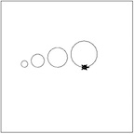
2. 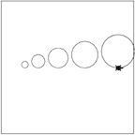
3. 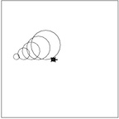
4. 